**Introduction to Bootstrap**

Bootstrap is a free front-end framework for faster and easier web development. Bootstrap includes HTML and CSS based design templates for typography, forms, buttons, tables, navigation, modals, image carousels and many other, as well as optional JavaScript plugins. Bootstrap also gives you the ability to easily create responsive designs.

**Responsive Web Design** : Creating websites which automatically adjust themselves to look good on all devices, from small phones to large desktops.

**Objectives**

* To understand the structure and usage of Bootstrap 5
* To use Bootstrap components like navbar, card, button, and modal.

**Bootstrap History**

Bootstrap was developed by Mark Otto and Jacob Thornton at Twitter and released as an open-source product in August 2011 on GitHub. In June 2014 Bootstrap was the No.1 project on GitHub.

**Where to Get Bootstrap 5?**

There are two ways to start using Bootstrap 5 on your own web site.

* Include Bootstrap 5 from a CDN
* Download Bootstrap 5 from getbootstrap.com

*Note: The main difference between Bootstrap 5 and Bootstrap 3 & 4 , is that Bootstrap % has switched to JavaScript instead of jQuery*

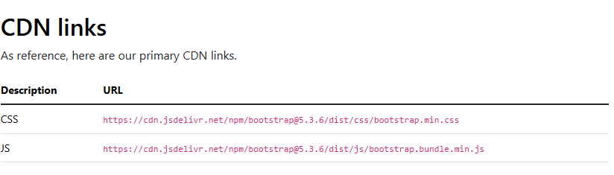

**Mobile First**

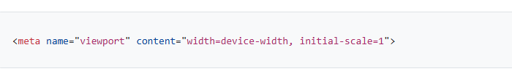Bootstrap is developed mobile first, a strategy in which we optimize code for mobile devices first and then scale up components as necessary using CSS media queries. To ensure proper rendering and touch zooming for all devices, add the responsive viewport meta tag to your <head>

**Create Your First Web Page With Bootstrap 5**

**Source code**

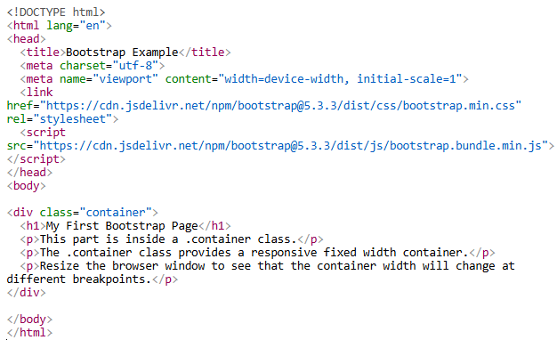

**Output**

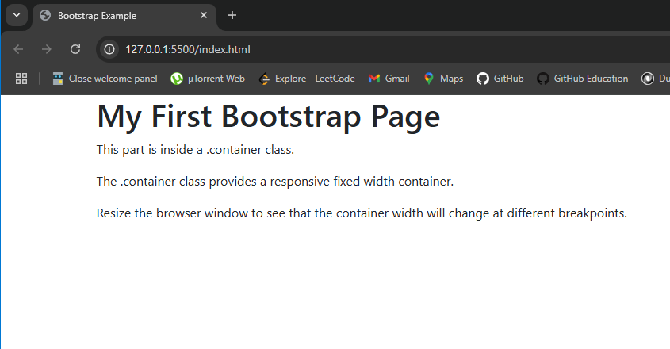

**Containers**

Containers are a fundamental building block of Bootstrap that contain, pad, and align your content within a given device or viewport. There are two container classes available:

1. The .container class provides a responsive fixed width container.
2. The .container-fluid class provides a full width container, spanning the entire width of the viewport.

**Responsive Container**

You can also use the .container-sm|md|lg|xl classes to create responsive containers. The max-width of the container will change on different screen sizes/viewports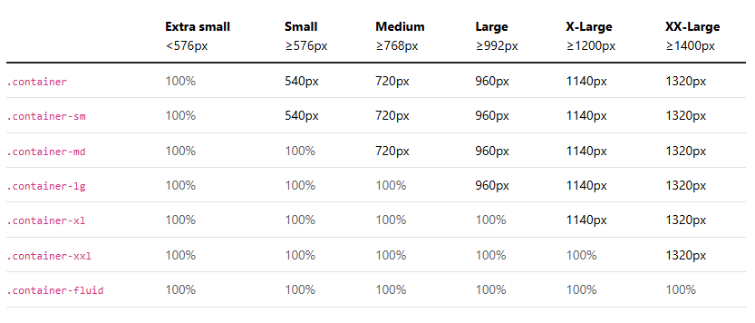

**Grid**

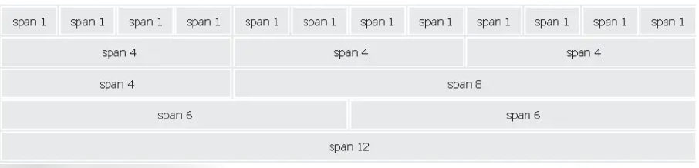Bootstrap's grid system is built with flexbox and allows up to 12 columns across the page. If you do not want to use all 12 columns individually, you can group the columns together to create wider columns:

The Bootstrap 5 grid system has six classes: (The classes above can be combined to create moredynamic and flexible layouts)

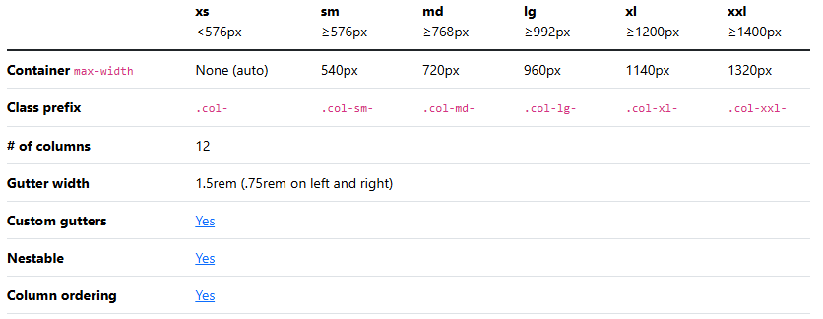

**Tables**

A basic Bootstrap 5 table has a light padding and horizontal dividers.

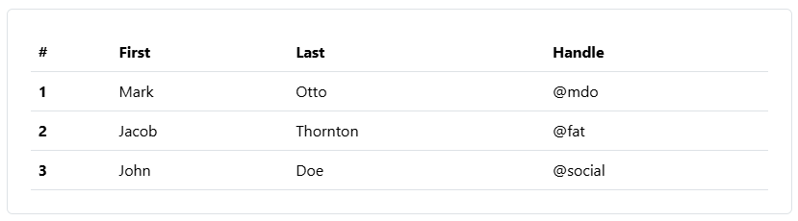

We can use contextual classes to color tables, table rows or individual cells.

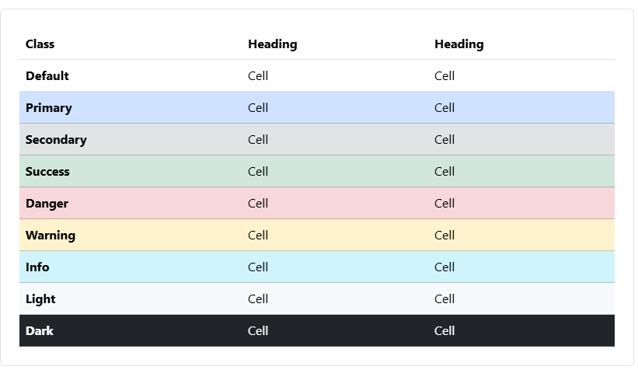

**Alerts**

Bootstrap 5 provides an easy way to create predefined alert messages. Alerts are created with the .alert class, followed by one of the contextual classes(.alert-success, .alert-info, .alert-warning, .alert-danger, .alert-primary, .alert-secondary, .alert-light or .alert-dark:)

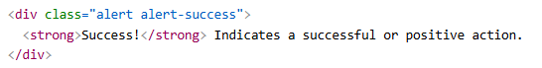

Example

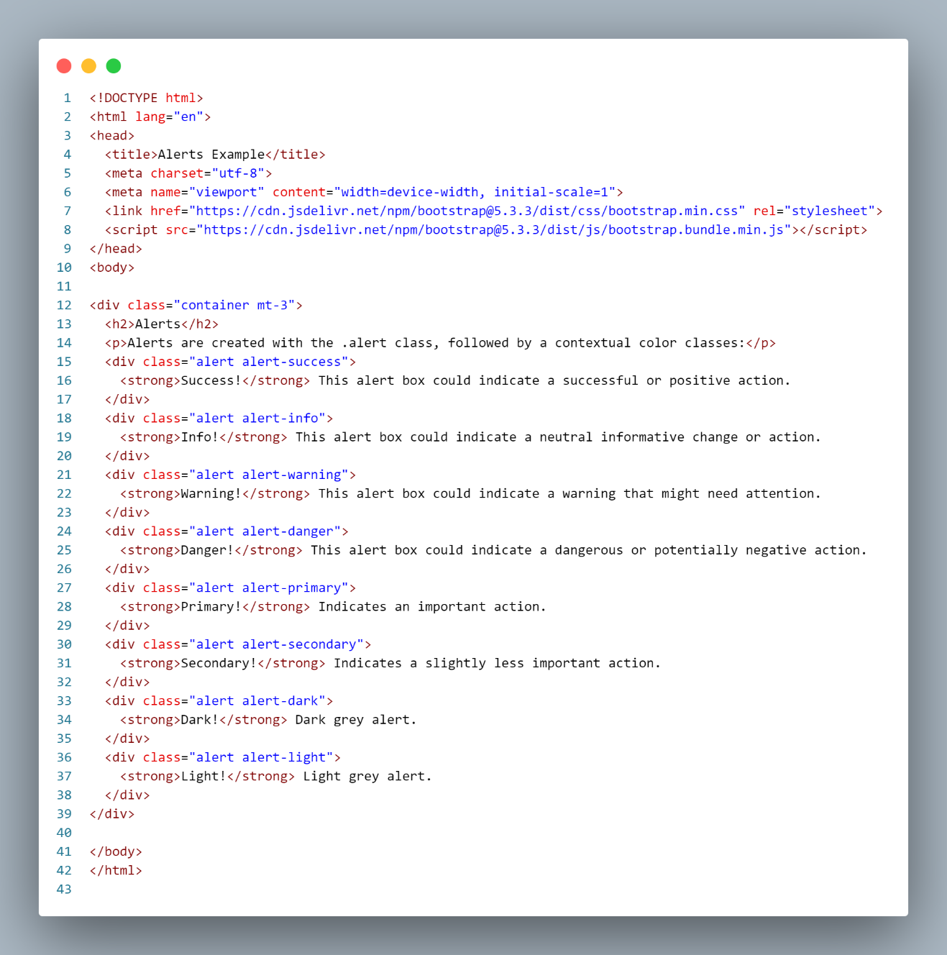

**Output:**

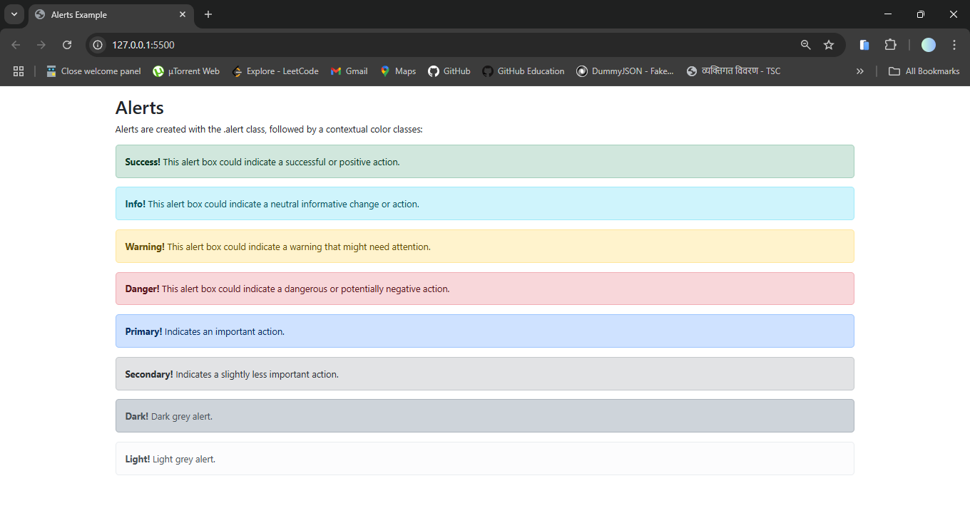

**Badges**

Badges are used to add additional information to any content. Use the .badge class together with a contextual class (like .bg-secondary) within <span> elements to create rectangular badges. Note that badges scale to match the size of the parent element (if any):

Example :

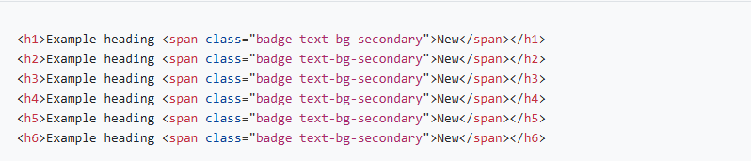

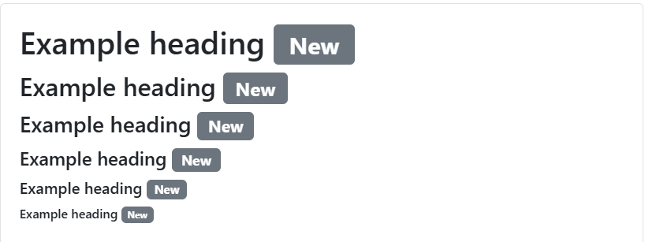

**Nav Bars**

A navigation bar is a navigation header that is placed at the top of the page. With Bootstrap, a navigation bar can extend or collapse, depending on the screen size.

A standard navigation bar is created with the .navbar class, followed by a responsive collapsing class: .navbar-expand-xxl|xl|lg|md|sm (stacks the navbar vertically on xxlarge, extra large, large, medium or small screens).

To add links inside the navbar, use either an <ul> element (or a <div>) with class="navbar-nav". Then add <li> elements with a .nav-item class followed by an <a> element with a .nav-link class.

Example

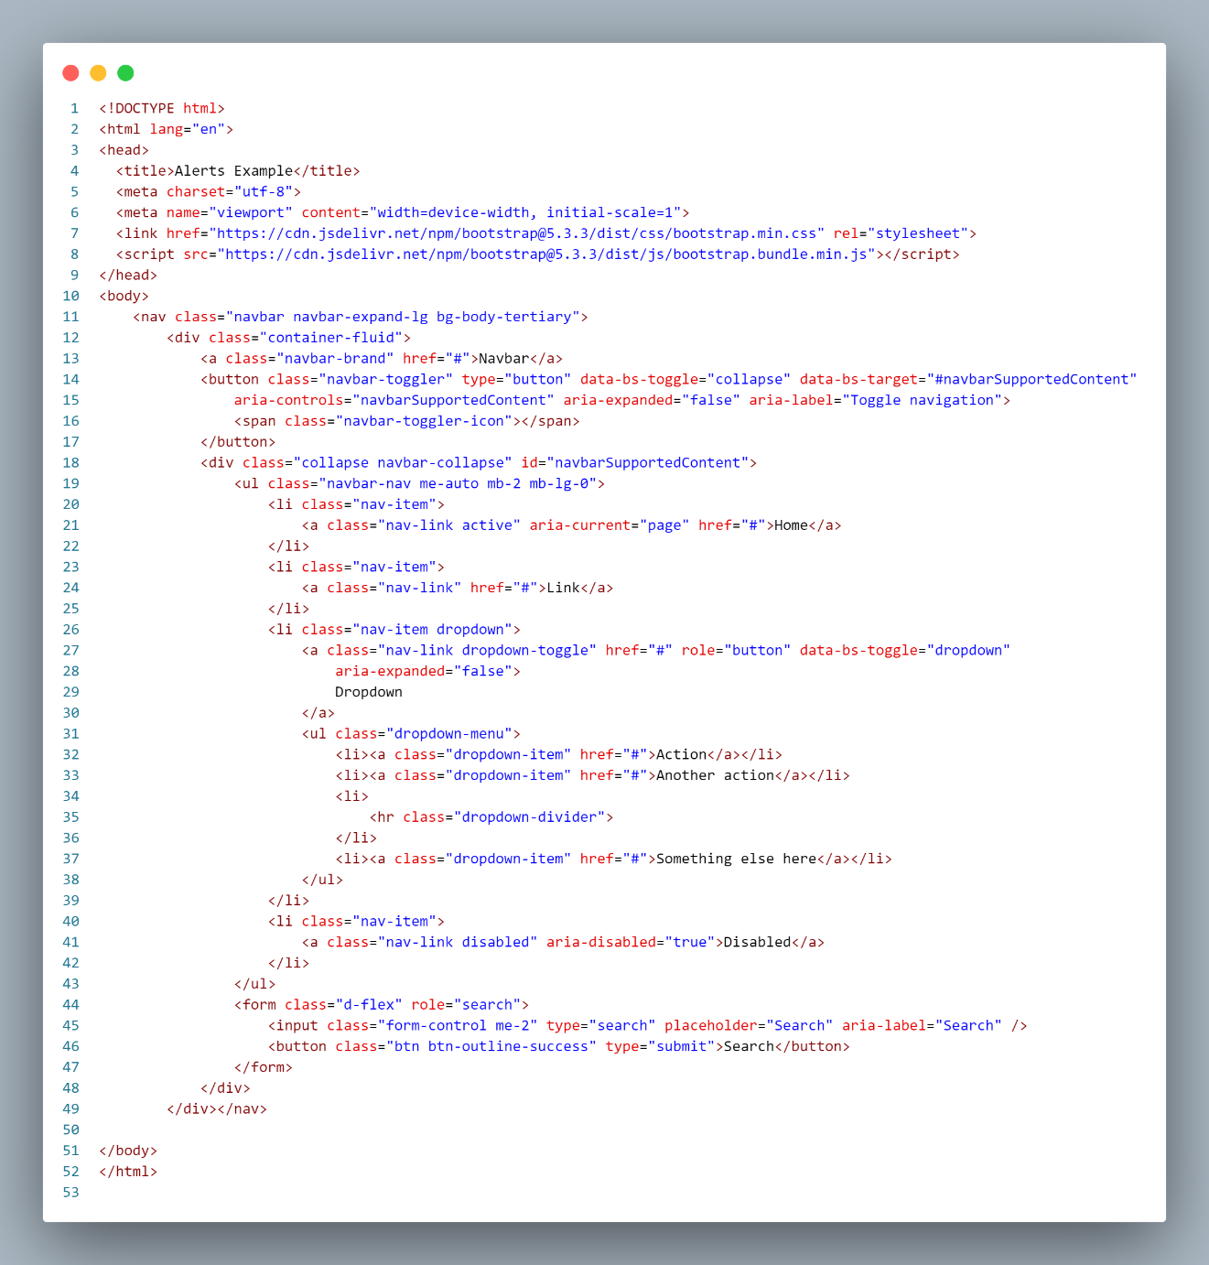

**Output**

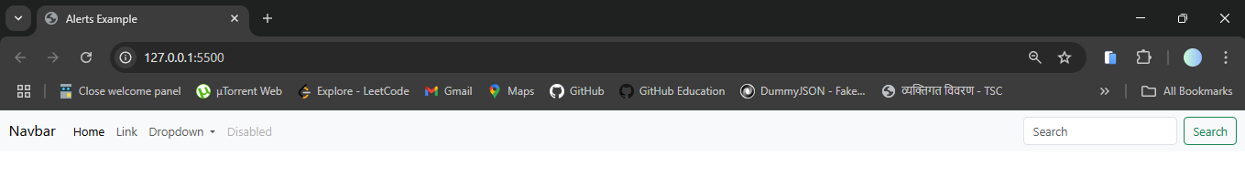

**Bootstrap Examples**

We can also use the templates form the examples bootstrap provided.

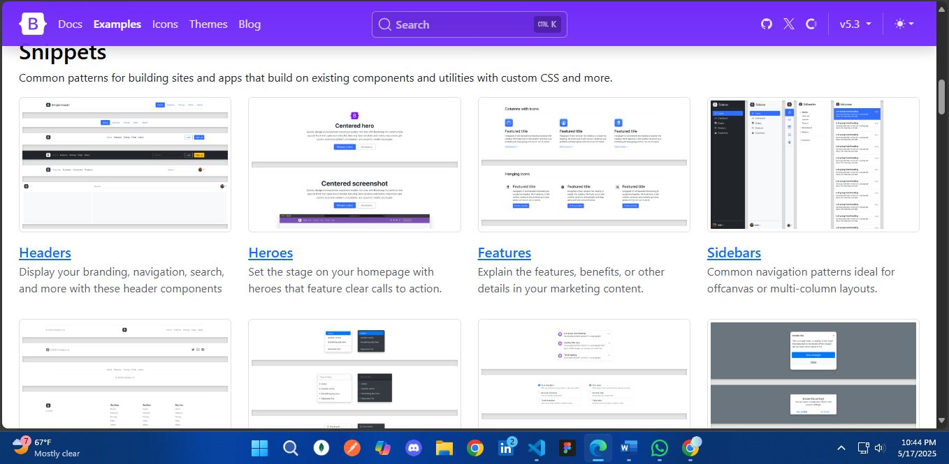

**Conclusion**

Bootstrap 5 provides a modern and efficient way to build responsive and attractive webpages quickly. With utility classes and built-in components, developers can save time and ensure mobile-friendliness.